EMPLOYEE PERFORMANCE ANALYSIS BASED ON COMPENSATION, MOTIVATION AND WORK ENVIRONMENT AT PT SUPPORT LOGISTIC INDONESIA

Firly Dwi Ainur Rochmah¹
Universitas Pembangunan Nasional “Veteran” Jawa Timur, Surabaya, Indonesia
21042010049@student.upnjatim.ac.id

Jojok Dwiridotjahjono²
Universitas Pembangunan Nasional “Veteran” Jawa Timur, Surabaya, Indonesia

Dwiridotjahjono_jojok@upnjatim.ac.id

Abstract
This study analyzes the impact of compensation, motivation, and work environment on employee performance at PT Support Logistic Indonesia. A quantitative approach is applied using a survey method, with data collected through questionnaires and analyzed using multiple linear regression. The results show that compensation, motivation, and work environment collectively have a significant effect on employee performance. Partially, compensation and work environment significantly influence performance, while motivation has no impact. These findings suggest that enhancing employee welfare through fair compensation policies and fostering a conducive work environment can optimize employee performance.

Keywords: Compensation, Motivation, Work Environment, Employee Performance

INTRODUCTION
Employee performance is crucial in helping a company achieve its business goals. Companies with productive employees are better able to compete and grow compared to those with productivity issues. Compensation, motivation, and work environment are some of the factors that can influence employee performance. These three factors are essential for creating a stable work environment, enhancing creativity, and fostering loyalty to the organization. Companies provide compensation to employees as a form of reward. This can take the form of salary, benefits, incentives, and facilities that can boost employee morale. Fair and competitive compensation, according to Harsanto & Ferijanti (2024), can accelerate employee performance and foster greater loyalty to management. If wages are inadequate, it can reduce work commitment and lead to employee turnover.
Motivation also influences employee activities. The factors that drive you to work can come from intrinsic or extrinsic sources. Intrinsic factors include personal satisfaction, a sense of achievement, and career advancement, while extrinsic sources include external rewards such as bonuses, job promotions, and recognition for your work. According to Mangkunegara (in Agung M. et al., 2019), employees with high motivation tend to be more productive, creative, and better engaged in their work. On the other hand, employees with low motivation tend to perform poorly, lack initiative, and are at risk of leaving the company. The work environment also significantly influences employee performance. Physical aspects such as cleanliness, lighting, and ventilation, as well as adequate work equipment, are part of comfort standards. Additionally, psychological factors such as organizational culture, inter-employee relationships, and managerial support influence how comfortable and motivated employees feel. Nitisemito (in Ayunasrah Tisnawati et al., 2022) adds that being in a supportive environment can enhance enjoyment, reduce stress, and help employees achieve their goals.
PT Support Logistics Indonesia is the official distributor of PT Sinar Sosro in Surabaya. The company employs 65 permanent employees across various departments, including sales, administration, warehouse, and drivers and assistants. The company has faced challenges in recent years regarding retaining employees and improving their productivity. Internal data from PT Support Logistics Indonesia shows that the number of employees resigning increased from 2022 to 2024. In 2022, 10 employees left the company. This number increased to 14 in 2023 and rose again to 16 in 2024. These figures indicate that the number of employees leaving the company has increased each year. This may suggest issues with the compensation system, motivation, or an unpleasant work environment. Additionally, employee attendance data shows a significant change in the rate of unauthorized absences. The highest rate was reported in April 2024, when 41 employees requested leave of absence.
This study aims to analyze the performance of PT Support Logistics Indonesia employees based on compensation, motivation, and work environment. It is also expected to provide recommendations to help the business manage human resources more effectively by understanding the relationship between these components.

REVIEW OF LITERATURE
Human Resource Management
Based on Hasibuan's (2019) perspective, HRM is the process of planning, managing, and developing the workforce in an organization to achieve company goals. In other words, it is the art and science of managing labor relations to achieve maximum and effective performance. In this study, HRM plays a role in ensuring employee welfare.
Compensation
Compensation is the reward provided by the company to employees for their efforts and dedication. According to Harsanto & Ferijanti (2024), it is divided into:
a. Direct financial compensation: Salary, wages, incentives, and bonuses.
b. Indirect financial compensation: Health benefits, transportation, and other work facilities.
Inadequate compensation can lead to job dissatisfaction, which may increase employee turnover rates. Therefore, adjusting compensation in line with effort is an important strategy for retaining employees.
Motivation
Motivation is defined as the desire that drives individuals to achieve desired outcomes. According to Mangkunegara (in Agung M. et al., 2019), work motivation can come from internal or external factors.
a. Intrinsic motivation: Internal drives such as personal satisfaction and goal achievement.
b. Extrinsic motivation: External factors such as awards, promotions, and financial compensation.
High motivation increases employee productivity and loyalty, while a lack of motivation can lead to decreased performance and increased resignation rates.
Work Environment
The work environment encompasses all aspects that influence employees in performing their duties. According to Nitisemito (in Ayunasrah Tisnawati et al., 2022), a good work environment can foster employee dedication and effectiveness. The factors include:
a. Physical environment: Cleanliness, lighting, ventilation, and work facilities.
b. Non-physical environment: Interpersonal relationships among employees, organizational culture, and company policies.
A poor environment can dampen morale and lead to high absenteeism rates at the workplace.
Employee Performance
This refers to the output achieved based on the criteria set by the company. According to Mangkunegara (in Sihaloho & Siregar, 2019), performance is influenced by internal factors (motivation, skills, and discipline) and external factors (work environment, leadership, and compensation systems). Performance indicators include:
a. Work quality: Accuracy and precision.
b. Work quantity: The volume of tasks that can be completed within a specific period.
c. Work creativity: The ability to generate new and innovative ideas.
Ideal employee performance brings significant benefits to company growth, while low performance can hinder the achievement of organizational targets.

Figure 1
Framework
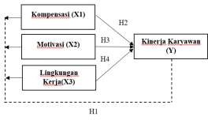
H1: There is a simultaneous effect on compensation, motivation, and work environment on employee performance at PT Support Logistic Indonesia
H2: There is a partial influence of compensation on employee performance at PT Support Logistic Indonesia
H3: There is a partial influence of motivation on employee performance at PT Support Logistic Indonesia
H4: There is a partial influence of the work environment on employee performance at PT Support Logistic Indonesia

RESEARCH METHOD
The observation was conducted using a quantitative approach at PT Support Logistic Indonesia, located in the SIER industrial area, JL. Rungkut Industri III, No. 33-A. The population included all 65 employees. The sampling technique used was saturation sampling, where all members of the population were included as samples. Information was collected through questionnaires and documentation to support the analysis.
Conducted to ensure that the regression model meets statistical requirements. Normality tests are performed to examine data distribution, which can be considered normal if the significance level is > 0.05. Multicollinearity tests measure the correlation between independent variables, with no multicollinearity indicated if VIF < 10 and Tolerance > 0.10. A heteroscedasticity test is performed using the Glejser method to ensure that the residual variance in the regression equation remains constant. If the significance level is > 0.05, there is no heteroscedasticity, and the model is considered valid. Additionally, an autocorrelation test using the Durbin-Watson (DW) test is conducted to detect correlation among residuals. The model is said to be free of autocorrelation if the DW value is in the range du < DW < 4 - du.

RESULTS AND DISCUSSION
Validity Test
Used to identify whether the data is correct or not.
Table 1.
Validity Test Results

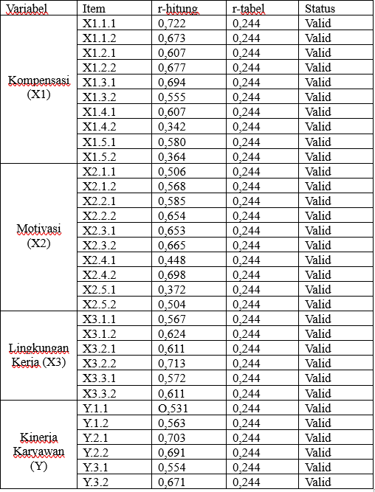
Source: Primary Data After Processing
Referring to the data presented, it can be concluded that the calculated r value is greater than the table r value, and the data has been proven to be accurate.
Reliability Test
Test and ensure that the questions asked to respondents can produce stable answers.
Table 2.
Reliability Test Results
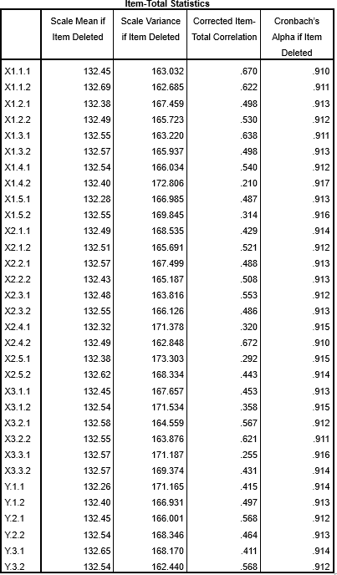

Source: Processed Primary Data
Based on the results, all questions had a Cronbach's Alpha (α) value > 0.90 from 32 questions and 65 respondents. Thus, this reliability test showed a perfect level of reliability.
Normality Test
Proves whether the data in a sample is normally distributed or not
Table 3.
Normality Test Results
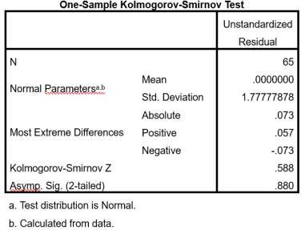

Source: Processed Primary Data

Based on the table above, it can be interpreted that the significance value of the SPSS calculation is 0.880. This indicates that all data from the 32 questions and 65 respondents are normally distributed.
Multicollinearity Test
A model is considered good when there is no multicollinearity effect.
Table 4.
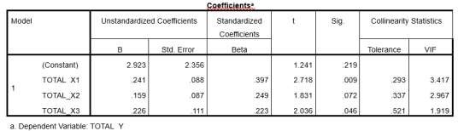
Multicollinearity Test Results
Source: Processed Primary Data
From the results of the Multicollinearity Test above, it can be said that:
a. The Tolerance value of X1 is 0.293 > 0.10 and the VIF value is 3.417 < 10.00, which means that there is no multicollinearity between the independent variables.
b. The Tolerance value for X2 is 0.337 > 0.10 and the VIF value is 2.967 < 10.00, meaning there is no multicollinearity among the independent variables.
c. The Tolerance value for X3 is 0.521 > 0.10 and the VIF value is 1.919 < 10.00, meaning that there is no multicollinearity among the independent variables.
Heteroscedasticity Test
The condition is that if the Significance Value (>0.05), then the conclusion is that there is no heteroscedasticity.
Table 5.
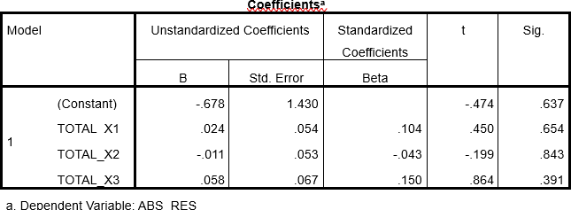
Heteroscedasticity Test Results

Source: Processed Primary Data
Autocorrelation Test
A comparison of the calculated Durbin-Watson value and the table value can be used to identify autocorrelation.
Table 6.
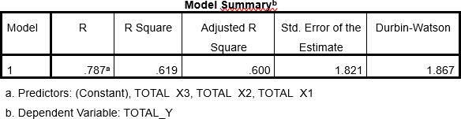
Autocorrelation Test Results
Source: Processed Primary Data
The Durbin-Watson (DW) value of 1.867 is between the lower limit (1.6960) and the upper limit (2.304), so the regression model is free from autocorrelation problems.
Multiple Linear Regression Analysis
The aim is to identify the strength of the relationship between the independent and dependent variables.
Table 7.
Multiple Linear Regression Analysis Results
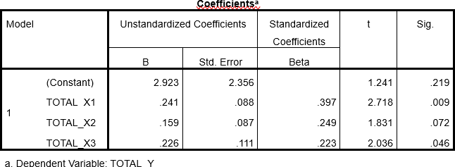

Source: Processed Primary Data
The above equation proves that the three independent variables are closely related to employee performance (Y). In other words, performance will improve if the value of one or all of the independent variables increases.
Simultaneous Test (F test)
Used to analyze whether the three independent variables together influence the dependent variable.
Table 8.
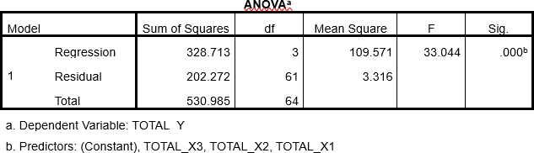
Simultaneous Test Results (F test)
Source: Processed Primary Data
The results show that the significance value is 0.000 (<0.05) and the F-value is 33.044 (>2.75), indicating that all three variables simultaneously influence employee performance.
Partial Test (T-test)
Used to prove assumptions 1 and 2, namely, to compare the effects of independent variables.
Table 9.
Partial Test Results (T-test)
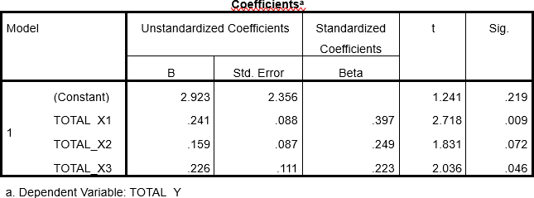

Source: Processed Primary Data

1. Testing X₁ against Y
The significance value of 0.009 (<0.05) and the t-value of 2.718 (>1.999) indicate that H₀ is rejected and H₂ is accepted, so X₁ has a significant effect on Y.
2. Testing X₂ against Y
The significance value of 0.009 (<0.05) and the t-value of 2.718 (>1.999) indicate that H₀ is rejected and H₂ is accepted, thus X₁ has a significant effect on Y.
3. Testing X₃ against Y
The significance value of 0.046 (<0.05) and the t-value of 2.036 (>1.999) indicate that H₀ is rejected and H₄ is accepted, thus X₃ has a significant effect on Y.
Determinant Coefficient
A regression test is used to calculate the percentage of influence between two or more independent variables on a dependent variable.

Table 10.
Determination Coefficient Test Results
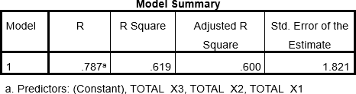

Source: Processed Primary Data

According to Table 1.10, the R Square value of 0.600 indicates that the three variables affect employee performance (Y) by 60%, while 40% is influenced by other factors.
The Effect of Compensation, Motivation, and Work Environment on Employee Performance at PT Support Logistic Indonesia
The test results show that employee performance, the dependent variable, is influenced by all independent variables. This is evidenced by a significance value of 0.000, which is greater than the 0.05 threshold, and a calculated F-value of 33.044, which is greater than the F-table value of 2.75. Therefore, H1 is accepted. Therefore, it can be concluded that compensation, motivation, and the work environment simultaneously have a significant effect on employee performance.
The Effect of Compensation on Employee Performance at PT Support Logistic Indonesia
With a significance value of 0.009 (<0.05) and a calculated t-value of 2.718 (>1.999), the regression results indicate that compensation has a significant effect on employee performance. Therefore, H2 is accepted.
The Effect of Motivation on Employee Performance at PT Support Logistic Indonesia
Shows a significance value of 0.072 and a calculated t-value of 1.831 (less than 1.999), so H3 is rejected. In other words, motivation does not depend on employee performance.
The Effect of Work Environment on Employee Performance at PT Support Logistic Indonesia
With a significance value of 0.046 (below 0.05) and a calculated t-value of 2.036 (greater than 1.999), the regression test indicates that the work environment has a significant impact on employee performance. Therefore, H4 is accepted.

CONCLUSION
Based on the results of the analysis and discussion, it can be concluded that the variables of Compensation (X1), Motivation (X2), and Work Environment (X3) collectively have a significant influence on employee performance, thereby supporting the acceptance of hypothesis (H1). The partial test results further reveal that the Compensation variable (X1) significantly affects employee performance, confirming the acceptance of hypothesis (H2). In contrast, the Motivation variable (X2) does not have a significant impact on employee performance, leading to the rejection of hypothesis (H3). Meanwhile, the Work Environment variable (X3) demonstrates a significant role in influencing employee performance, thus supporting the acceptance of hypothesis (H4).

Recommendation
In light of these findings, several recommendations are proposed to enhance employee productivity and well-being. PT. Support Logistic Indonesia should revise its compensation policies to ensure fairness and competitiveness by increasing salaries, offering performance-based bonuses, and providing additional benefits such as health and transportation allowances, which can improve satisfaction, reduce turnover, and strengthen loyalty. Although motivation did not show a significant partial effect, the company should continue implementing training programs, workshops, and both financial and non-financial rewards to boost morale and productivity. Furthermore, the company should create a conducive and productive work environment by upgrading facilities, fostering balanced workplace relationships, and maintaining harmony between professional responsibilities and employees’ personal lives.

REFERENCES
Agung, M., Djunaidi, D., & Astutik, P. (2019). Pengaruh Kompensasi, Motivasi Dan Lingkungan Kerja Terhadap Kinerja Pegawai Unit Pelaksana Teknis Dinas Pengelolaan Sumber Daya Air Kabupaten Nganjuk. JIMEK: Jurnal Ilmiah Mahasiswa Ekonomi, 2(1), 85-100.
Ayunasrah, T., Ratnawati, R., Diana, R., & Ansari, A. (2022). Pengaruh Lingkungan Kerja Terhadap Kinerja Pegawai Dengan Kepuasan Kerja Sebagai Variabel Mediasi Pada Dinas Lingkungan Hidup Kabupaten Bener Meriah. Jurnal Ilmiah Ilmu Manajemen, 4(1), 1-10.
Harsanto, A. D. H., & Ferijani, A. (2024). Pengaruh Kompensasi, Lingkungan Kerja, Dan Motivasi Kerja Terhadap Kinerja Karyawan Divisi Sentra UMKM PT Bank Central Asia Di Kota Semarang. Management Studies And Entrepreneurship Journal (MSEJ), 5(2), 4258-4268.
Jannata, A., & Tura, T. B. (2024). Pengaruh Kompetensi Dan Motivasi Kerja Terhadap Kinerja Pegawai Pada Upk (Unit Pelaksana Kebersihan) Badan Air Kecamatan Cilandak Jakarta Selatan. Musytari: Neraca Manajemen, Akuntansi, dan Ekonomi, 4(5), 43-53Jenita, N. K. S. (2023). Pengaruh Job Description, Sistem Kerja Dan Pelatihan Kerja Terhadap Produktivitas Kerja Pegawai Pada Dinas Sosial Kabupaten Gianyar (Doctoral Dissertation, Universitas Mahasaraswati Denpasar).
Sihaloho, R. D., & Siregar, H. (2020). Pengaruh Lingkungan Kerja Terhadap Kinerja Karyawan Pada PT. Super Setia Sagita Medan. Jurnal Ilmiah Socio Secretum, 9(2), 273-281.
Toha, Mohamad & Supriyanto. (2023). Factors Influencing the Consumer Research Process: Market Target, Purchasing Behavior and Market Demand (Literature Review Of Consumer Behavior). Danadyaksa: Post Modern Economy Journal, 1(1), 1–17. Retrieved from https://e-journal.bustanul-ulum.id/in
Utamy, R., Ahmad, S., & Eddy, S. (2020). Implementasi manajemen sumber daya manusia. Journal of Education Research, 1(3), 225-236.
Toha, M. (2019). Derivatif Versus Ekonomi Syariah. Indonesian Interdisciplinary Journal of Sharia Economics (IIJSE), 2(1), 91-102. https://doi.org/10.31538/iijse.v2i1.328

